Slope stability issues close to local road P130 near the town Sabile, in Latvia – case story
Problème de stabilité d’une pente près de la route P130 non loin de la ville de Sabile, Lettonie – exemple pratique
M. Grava
Latvian State Roads SJSC, Riga, Latvia

ABSTRACT: Case story about infrastructure object – road, and slope stability issues close to that. A topic of this paper is an evaluation of the situation from road management point of view with specific attention to geotechnical investigation management. During reconstruction works of the road in parts of the slope, that was cut in with the road reconstruction works, there was observed soil mass displacements. Dimensions of the soil mass displacement zone: length approx. 300 meters; with approx. 30 meters, slope height at impacted zone 10 ... 12 meters. Designed project execution has influenced the stability of the slope and there was not possible to finish construction works according to the design. Main issues related to the construction of the gabion wall, that supposedly should keep stable situation in the upper part of the slope (from the road point of view). Slope instability is an issue for finishing road reconstruction works. What kind of influence was and still have geotechnical investigations in this road reconstruction project? At this moment (beginning of the year 2018) due to an unsolved geotechnical situation at the object, reconstruction of the road has not been finished and slope instability is observed at the site. Most likely, geotechnical investigations will be continued.

RÉSUMÉ: Exemple portant sur l’infrastructure : problème de stabilité de la route et de la pente qui la longe. Cet article met l’accent sur l’évaluation de la situation du point de vue du gestionnaire de la route en attachant une attention particulière à la prévision et à la réalisation des travaux géotechniques. Pendant la reconstruction de la route, on a observé des glissements de terrain du côté de la pente où des excavations ont été réalisées. Les dimensions du terrain glissant : longueur d’environ 300 mètres ; largeur d’environ 30 mètres ; hauteur de la pente concernée 10 ... 12 mètres. La réalisation des travaux a impacté la stabilité de la pente, et l’achèvement des travaux de construction conformément au projet n’était plus possible. La difficulté principale était liée à la construction d’un mur en gabion qui devait garantir la stabilité de la pente. La pente par rapport à la route se trouvant plus haut. Le manque de stabilité de la pente est un obstacle qui empêche l’achèvement des travaux de reconstruction. Quel était, et est encore, le rôle d’une étude géotechnique dans ce projet de reconstruction de route ? Actuellement (début 2018), en raison de la situation géotechnique non résolue, les travaux de reconstruction de la route ne sont pas achevés et des signes d’instabilité de la pente ont été observés. Les études géotechniques seront probablement prolongées.

Keywords: geotechnical investigation; project management; slope stability

INTRODUCTION
To achieve a successful result of the reconstruction project, all parties involved in the execution of the project should perform their best. That includes the client, project consultant, and construction contractor. Subcontractors of one or all the previously mentioned parties, including investigation work performers, are expected to do the same.
This case story is regarding road P130 reconstruction. At the project design phase, consultant subcontracted geotechnical and topographical investigation parties. Road reconstruction works were ongoing but could not be finished and executed according to design due to stability failure in part of the slope located close to the road (in connection with). Slope instability process showed active phase during excavation works - cut in in the slope, to prepare zone for gabion type retaining wall (according to design). Construction works at the affected road zone were stopped, and the situation left as it is. Slope slip affected areas not only within the reconstruction project zone but also areas outside of that, upwards and downwards at the slope in the topographical view.
Client (road administrator, responsible for road reconstruction work management) performed two attempts (till the middle of the year 2018), to solve slope instability issues. Design project for slope stabilization work was ordered. First design attempt was not successful due to the consultant’s refusal to use data from geotechnical investigation work, that was contracted directly by the client after slope stability failure, separate from previously mentioned road reconstruction project. The second attempt was stopped due to landowner refusal of giving permission to execute another investigation work on his land. Area, affected by the slope slip and outside of the roads legal borders, is owned by other parties.
There are several geotechnical investigations (GI) performed and at least one is planned, at the slope slip affected area, at this moment. Those are: GI ordered by the client during the road reconstruction design phase; GI requested extra by road reconstruction consultant; GI performed shortly after slope instability occurrence; GI for slope stabilization project needs. Last two GI are ordered directly by the client. And there is at least one more GI performed in this area, 56 years ago, with the aim to understand slope instability issues that were observed at that time.

Location
The site is located at the western part of Latvia, approx. 3 kilometers to east from town Sabile, close and interfering with road P130. Road P130 cuts through slope from upland with height markings 80...84 meters above sea level (m a.s.l.) upper part and 32...34 m a.s.l. at the lower part. Slope instability occurred at slope part 50...60 m a.s.l., with location above road P130. The site is in the Abava river old valley. Abava river reaches 150 meters distance at the closest point to road P130 at the slope slip area.
Slope angle at the site is in range of 20...30 degrees, in separate sections of 45...55 degrees. At the semi-stable zone of slope slip that occurred in the year 2014, the angle of the slope is in the rage of 30...35 degrees (surveyed in the year 2018).
Slope length near the road that was changed during road reconstruction works in the year 2014 was approx. 300 meters. In the year 2014 slope slip affected area was within of 155 meters of road length and 35 m slope length above the road. In the year 2018 slope slip affected road length is measured up to 185 meters distance.

Geology and hydrogeology
The site lies within Abava river valley and this factor has a major role in the geological structure of the slope and the subgrade of the road P130. Modern time river Abava lies close to the site, up to 150...350 meters. The closeness of the modern river is not considered the main issue of the instability of the slope.
According to results of the investigation works (in the year 1962, 2015, 2016) it is inferable that, groundwater and rainwater accumulation in the imbedding’s of the slope and over saturation of the clayey - silty deluvial (slopes upper layers), are the main reasons of the slope instability.
This assumption is referred to slope slip, that affected road P130 construction from kilometer 14,00 till 14,20 at the slope elevation approx. 50 m a.s.l. and slope itself at the maximum distance from road 35 meters towards the upper part of it. There is no available information or data to author of this paper regarding the instability of the whole or more parts of the slope from 30 up to 80 m a.s.l.

3.1 Geological structure
Available geological and geotechnical investigation reports (Latdoravtoprojekt, 1962; Silurs 2013, BMGS, 2015; Firma L4, 2016) enclose geological information that can be summarized as follows.
Slope is made of the Devonian period sandstone, carbonates (dolomites, domerites etc.), clays, aleirolites that are eroded unevenly at the part of the valley walls and covered with deluvial type clayey – silty material. GI uncovered glaciofluvial clayey silt at the upper parts of the slope. But closer to river Abava, also sandy and gravely materials.
Devonian sediment description accordant to GI report prepared by BMGS, 2015:
Clay – consistency stiff up to firm with separate interlayers of soft to very soft clay. The consistency of the soil rises with closeness to the top of the surface, due to the influence of the water (infiltrated and surface waters). Clay layers enclose interlayers (less than 0,2 meters) of dolomites, aleirolites, sandstones.
Aleirite (aleirolite) – discovered as interlayers in clay strata. Aleirite is sand – clay type sediment, that consists of particles in size of 0,01 up to 0,1 millimeters. Aleirite has no cementation as a difference from aleirolite. These sediments are presenting regular water saturated interlayers in the geological cross section.
Dolomite and domerite – dolomite has medium strong up to strong compressive strength with cracks and interlayers (2...10 centimeters) of clay and domerite. Domerite has a low-pressure capacity.
Sandstone – is weakly cemented and dense material. Particle sizes from 0,25 to 0,1 millimeters dominate 79...83% of the amount of tested soil sample.
Geotechnical investigation report from the year 2015 (BMGS), enclosed cross-sections reveals geological structure (see Figure 1).
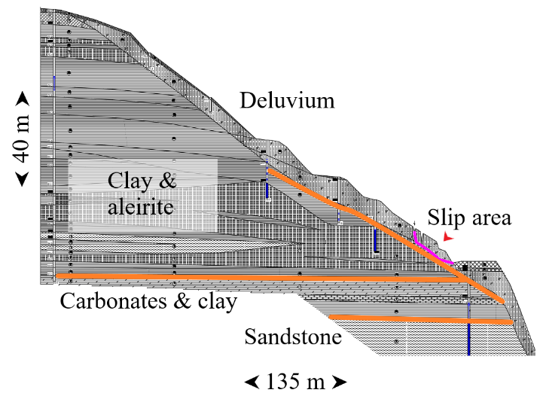
Figure 1. Geotechnical cross-section (BMGS, 2015 with comments)

Beneath road P130 down to elevation 32 m a.s.l. there is deluvial material at the main part of the slope slip site. That is approx. 80...90 meters length of road at the slope slip area. At the rest of the length of road that was enclosed in this investigation works, there is only one cross-section. That gives no data at the depth of the 32 m a.s.l.. Starting from depth approx. 40 m a.s.l. sandstone strata are shown, above that up to 46 m a.s.l. are carbonate (dolomites etc.) and clay layers. And from that depth up to road construction, that lies at the elevation 50 m a.s.l. there is deluvial material. In summary, at the longitudinal cross-section of the road length of 150 meters, the thickness of the deluvial material varies from 1 to 15 meters (approx.).
Above elevation 50 m a.s.l. deluvial sediment layer is partially saturated, water saturation of sand like sediments is highlighted in previous mentioned investigation reports. Deluvial material that lies lower elevation 50 m a.s.l. has not been displayed as saturated material.
In the upper part of the geotechnical cross-section clay strata is shown as unsaturated and in the lower parts saturated interlayers of the aleirite are shown. Approx. from 60 up to 55 m a.sl. (upper part of the slope slip) aleirite is considered water saturated (BMGS, 2015). According to information enclosed in investigation reports (Latdoravtoprojekt, 1962; BMGS, 2015; Firma L4, 2016), aleirite delivered water and precipitation water caused oversaturation of the clayey material and stability loss of the slope.

Geotechnical investigations to solve slope instability problem

4.1 History
Before this particular case (slope slip) in the year 2014, there is geological investigation report from the year 1962 that investigates slope instability problem at the site (Figure 2) and areas close to that (in a rage of couple hundred meters). In this (Latdoravtoprojekt, 1962) investigation report information is given about slope slip occurrences in the year 1954 during reconstruction work of the road. Information is given regarding existing slope instability solutions - existing concrete wall with a drainage system (not working). There is also mentioned existing trench, that has been made above connection road. As stated in the report – trench was working as precipitation water collector, not a drainage system.
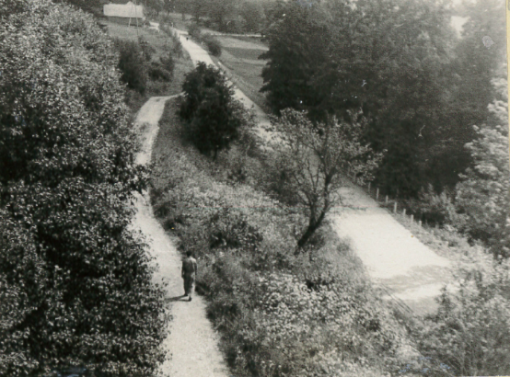
Figure 2. Slope slip area (Latdoravtoprojekt, 1962)

4.2 Year 2014 case
In the year 2013 design project was prepared. Design project dealt with several geotechnical problems in this area, like road embankment and slope instability. According to information that can be found in the design project, the slop slip problem supposed to be solved with gabion type wall (Figure 3). That wall was planned in the length of 120 meters, 4 meters in height and design location was approx. 4,5 meters from road pavement. Only cut in the slope was made, until slope slip occurred.
GI as a part of this design project was performed by a subcontractor of the consultant in the year 2013. Geotechnical investigation points were made on road and close part of it, but not in the direct location of gabion wall or more further away from the road towards the slope. The depth of investigation points was up to 4,5 meters. Investigation points where made with the method – soil sampling with drilling.

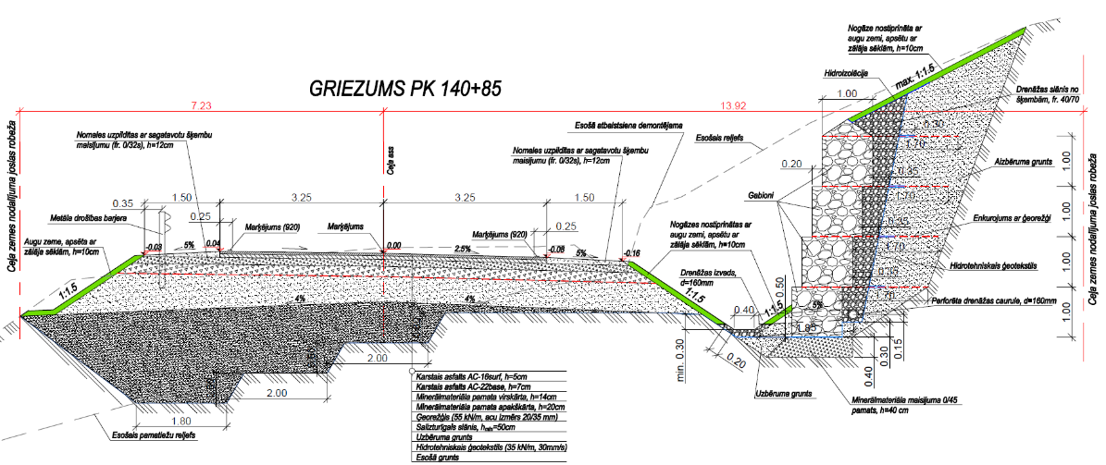
Figure 3. Cross section from design prepared in year 2013 (Polyroad, 2013)

There is no information in the investigation report regarding In-Situ tests or laboratory tests of the soil mechanical tests. There is information about determination physical properties of the soil in the laboratory. There is a summarization of soil types at the site and their mechanical properties. There are no indications, how mechanical properties where determined.
Regarding gabion wall stability calculations, there is information in the project, from which can be assumed that geological situation was considered as uniform one layer, not as described in the geotechnical report – complicated.
During construction works the road construction was fully built and cut in the slope for gabion wall was made. Slope slip occurred in October of the year 2014. Soil mass moved towards the road, gabion wall was not built and the situation was left as it is.

4.3 Year 2015 investigations
At the end of the year 2014 and till the beginning of the year 2015 GI were performed. Those were ordered by the client to find out slope slip occurrence reasons and receive valuable geotechnical data for separate design project regarding solutions of the soil mass slide. GI works took place at the slope slip area and an area close to that. Besides of soil sampling, In-Situ tests were performed – dynamic penetration tests and field vane tests. Soil samples were taken for laboratory tests not only to determine physical but also mechanical properties.

4.4 Year 2016 investigation phase
During several consultancies regarding possible solutions to resolve a problem of the slope slip, the client was convinced to order another GI. They should give more valuable data related to soil mechanical properties, data regarding slip surface and information about the placement of the eroded surface of Devonian carbonate rock mass. Those GI works were performed from January to May 2016. They included soil sampling with drilling and the test pits, static cone penetration tests with pore pressure measurements and laboratory tests.

4.5 Year 2016 design phase
After completion of the geotechnical works at the middle of the year 2016 client hired a consultant to deliver a project to solve slope slip problem. Draft version – proposal for the solution was received in August of the year 2016. To complete design the consultant requested another GI. Due to land owner’s refusal to give permission to perform more investigation works on his land, they not been executed and project design not completed till now – the year 2018.
Additional GI was requested by the consultant due to insufficient information in previous reports regarding: the filtration properties of the water-bearing layers – aleirite that is located above slop slip occurrence zone; lack of the data from cone penetration tests related to pore water dynamic overpressure in clayey soils; insufficient quantity data in geological cross-section at the contact zone of carbonate rock mass and deluvial material; insufficient quantity and quality of data regarding sandstone strata, that lies beneath of the carbonate rock mass. Last mentioned lack of the data regarding sandstone rock mass could be related more to needs of the proposed design rather than the quality and quantity of the previous investigations. Design project draft version proposed: gabion wall, approx. 3 meters in height and drainage behind that; ground anchors from gabion wall till sandstone rock mass; drill piles with length of 5 meters beneath of gabion wall; vertical drainage in the length of 30 meters; horizontal drainage at the depth of 15 up to 25 meters below slope surface, in length close to 100 meters.

4.6 Summarization scope of the geotechnical investigation works
The respective slope slip area was investigated three times within the period from the year 2013 to 2016. Amount of the investigation work has reached more than 300 meters in the boreholes & drill holes with soil sampling and with the depth of the investigation points from 0,3 up to 30 meters; more than 100 meters in the In-Situ tests; approx. 180 soil samples; more than 300 laboratory tests of the soil properties. The soil samples were tested on physical & mechanical properties: particle size distribution, Atterberg limits, consolidated drained direct shear test, un-/consolidated – undrained triaxial tests. Executed In- Situ tests: Dynamic penetration tests (DPL&DPSH); Cone penetration tests (CPTU); Field vane tests (FVT). Summarization of the geotechnical investigation work type and amount are given in Table 1.

Table 1. Summarization of the geotechnical work amount
Type / Year of the Investigation | Soil investigation points | In-Situ tests |  |  | Laboratory tests of the Soil properties
 |  | DPL & DPSH | CPTU | FVT | Physical | Mechanical
2014 | 36 | - | - | - | 25 | -
2015 | 44 | 39 | - | 40 | 191 | 28
2016 | 50 | - | 9 | - | 61 | 29
 | 130 | 39 | 9 | 40 | 277 | 57

Conclusions and DISCUSSION
Summarize the information that was found in the GI reports main issues of landslip can be identified. Water is seeping through aleirite interlayers from inner parts of the slope. Spring and precipitation water is collected by the small ponds. Water from both sources are combining critical mass what’s needed to oversaturate soil mass and active landslip occurred. There is some information in the investigation report from the year 1962, that land slip was happening constantly – not noticeable by eye.
When active landslip occurred (in the year 2014) and we were seeking a solution, appropriate geotechnical information is needed. Geotechnical data can be sufficient only when investigator knows what’s needed for the design.
At this timescale, we already had two GI with a direct task to collect data for slop slip problem solution design and even third is needed. Not the count of investigations, but the trend of this situation itself, is alerting. The situation, that gives a vision of never-ending story about insufficient quality and quantity of geotechnical data, is alerting. At this stage of the design a solution is proposed, where the affected area would be increased from 35 up to 100 meters in the view of the road cross section and in depth from 10 up to 35 meters. A question can be raised: how reasonable is that approach and should client rely on the consultant’s opinion by 100%?
How did we get to the problem – slope slip? Can it be predicted and prevented? Can GI give some prediction? From geotechnical investigation point of view, probably there is no reason to discuss the quality of geotechnical data in road reconstruction project (in the year 2013).
There are some or none investigations that are directly connected to designed gabion wall that should keep the slope stable. None, except investigation points (just drill points, no more) on road that were situated lower than slipped slope.
Sharing “Vision” of the solution between involved parties, could be the connecting link between the client, consultant, consultant’s subcontractors and contractor who undertakes to implement a design in the real life.

References
Ģeologu grupa Silūrs, Ltd 2013 Pārskats par ģeotehniskajiem izpētes darbiem P130 Līgas-Kandava-Veģi km13,950-14,250 un 14,800-15,300 ceļa klātnes deformāciju novēršana
Polyroad, Ltd 2013 Būvprojekts: Autoceļa P130 Līgas-Kandava-Veģi km13,950-14,250 un 14,800-15,300 ceļa klātnes deformāciju novēršana
BMGS, JSC 2015 Ģeotehniskās izpētes pārskats: Noslīdējumi autoceļa P130 Līgas-Kandava-Veģi posmos 13.95-14.25km un 14.80-15.30km
Firma L4, Ltd 2016 Ģeotehniskās izpētes pārskats: Ģeotehniskās informācijas iegūšana, sagatavošanas un apstrādes darbi Greiļu kalna noslīdeņa zonā autoceļa P130 Līgas-Kandava-Veģi km14.00-14.20
JMI Birojs, Ltd 2016 Būvprojekts (starpziņojums): Valsts reģionālā autoceļa P130 Līgas-Kandava-Veģi km 14,0-14,20 Greiļu kalna nogāzes noslīdeņa zonas stabilizācija
Latdoravtoprojekt,1962 ЛАТДОРАВТОПРОЕКТ ИНЖЕНЕРО-ГЕОЛОГИЧЕСКИЕ УСЛОВИЯ оползневого участка автодороги Тукумс-Кандава-Сабиле-Веги /Грейлю-Калнс/

