Road structure investigations for the optimization of road maintenance decisions
Enquêtes sur la structure routière pour l'optimisation des décisions d'entretien routier
M. R. Turk
ZAG Ljubljana, Ljubljana, Slovenia
M. Tušar
The National Institute of Chemistry, Ljubljana, Slovenia

ABSTRACT: The resistance to traffic loads of a road depends on the bearing capacity of soil layers underneath the pavement, the thickness of laid asphalt, and the fatigue resistance of the asphalt layers. Upgrading operations of existing roads range from maintenance (asphalt resurfacing or replacement) to rehabilitation and reconstruction (including earth-moving operations). Decisions about the scope of the needed works are often based on ride and surface quality determined by non-destructive testing such as visual inspection of pavement distress such as cracks, rutting, and ravelling. Road diagnosis usually includes tests to determine asphalt and bitumen characteristics. Sometimes it is also necessary to investigate the properties of the unbound layers beneath the pavement, at least to the freezing / thawing depth. The paper deals with the results of investigations into the properties of the asphalt and unbound layers of two existing roads. These activities showed that the road upgrading process should include experts from different fields of civil engineering in order to optimize road renewal or upgrading decisions and enable sustainable road construction and maintenance.

RÉSUMÉ: La résistance au trafic d'une route dépend de la capacité portante des couches de sol sous la chaussée, de l'épaisseur de l'asphalte posé et de la résistance à la fatigue des couches d'asphalte. Les travaux de modernisation des routes existantes vont de l'entretien (resurfaçage ou remplacement de l'asphalte) à la réhabilitation et à la reconstruction (y compris les opérations de terrassement). Les décisions relatives à l'étendue des travaux nécessaires reposent souvent sur la qualité du revêtement et des surfaces, déterminée par des essais non destructifs, tels que l'inspection visuelle de la détresse de la chaussée, telles que les fissures, les ornières et les ravelements. Les enquêtes routières comprennent généralement des tests visant à déterminer les caractéristiques de l'asphalte et du bitume. Parfois, il est également nécessaire d'étudier les propriétés des couches de graviers situées sous la chaussée, au moins jusqu'à la profondeur de gel / dégel. Dans l'article sont des résultats des enquêtes sur les propriétés de l'asphalte et des couches non liées de deux routes existantes. Ces activités ont montré que le processus de réparation des routes devrait inclure des experts de différents domaines du génie civil afin d'optimiser les décisions de rénovation ou de modernisation des routes et de permettre la construction durables de routes.

Keywords: diagnosis, road structure, asphalt, unbound layers, dynamic modulus E_{vd}

INTRODUCTION
In terms of tonne-kilometres (tkm), European road freight transport declined in 2011, reflecting the economic climate of that time. However in 2016 it increased by 4.5 % compared with 2015. In 2016, it was the highest for the last 5 years (Eurostat, 2017).
The resistance of roads to traffic loads depends on the bearing capacity of the soil layers underneath the pavement, on the thickness of the laid asphalt, and on the fatigue resistance of the asphalt layers. In countries with cold climates resistance to cracking at low temperatures also needs to be taken into account. If roads are properly designed, built, and maintained, then asphalt pavements should last without repaving for at least 20 years. However in Slovenia the traffic loads increased more rapidly than had been anticipated, so that motorways and main roads have needed earlier upgrading.

Road management
Proper road management should ensure an uninterrupted traffic flow and a high level of safety and comfort. Regular pavement condition monitoring is needed in order to supply road managers with information about the safety level and degradation of the pavement's wearing or ‘surf’ course.
Non-destructive testing, which includes several different methods, has become an integral part of pavement evaluation. Visual Condition Surveys are performed based on the results of data obtained by a vehicle travelling at normal speed. Several surface characteristics can be identified, i.e. rut depth, longitudinal profile (ride quality), and lengths of road with a deteriorating surface (e.g. cracking).
In the case of road upgrading to heavier traffic loads, the structural condition of flexible (asphalt) pavements needs to be assessed. The bitumen characteristics are also important from the point of view of sustainable construction and the reuse of the site-won asphalt granulate.
The structural condition of pavements is assessed by measuring their deflection under a known load. Deflectographs or falling weight deflectometers (FWD) can provide valuable information about pavement performance, thus enabling project prioritization at the network level. Deflectographs work on the principle that as a loaded wheel passes over the pavement, the latter deflects, and the size of the deflection is related to the strength of the pavement layers and the subgrade. On the other hand, in the case of falling weight deflectometers (FWD) a mass is dropped onto the road pavement. The resulting vertical force is transferred through a plate and creates a deflection that simulates a wheel load. The measured deflection is related to the combined stiffness of the component layers in the pavement and their ability to distribute the traffic loading. Ground-penetrating radar (GPR), a geophysical method that uses radar pulses to image the subsurface, can also be used for structural assessment. However the interpretation of such results is demanding, and needs calibration with coring of the asphalt.

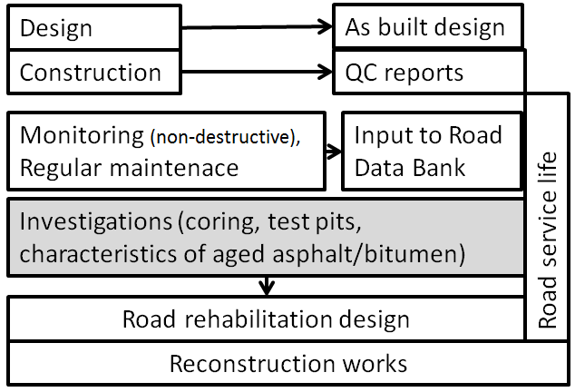
Figure 1. Road management activities

The scope of road management activities is presented in Figure 1. The current practice of pavement diagnosis which is implemented for the planning of the renewal or upgrading of main roads and motorways is presented in Sections 3 and 4, respectively.

MAIN Road DIAGNOSIS

Pavement monitoring
In the case of typical urban single-carriageway road sections (see Figure 2) the driving speed is limited to 50 km/h. Due to the above-mentioned increase in average daily traffic (ADT), the selected road section needs widening to two lanes. It is presently planned that the emergency lane will be upgraded to a driving lane for buses, in which case the existing driving lane will be mostly used by cars.

Figure 2. The selected main road – location No. 4L – left emergency lane

The results of FWD tests (with plate loads of 700 kPa) which were performed for this main road at the network level are presented in Figure 3. The measurements were performed at every 100 m on the existing driving lane, but no measurements were performed on the emergency lane. From the numerous tests only five results are presented near the locations where test pits were later excavated. However, since the heavy traffic will be transferred from the existing driving lane to the existing emergency lane, these results are not relevant. The results of FWD measurements are usually presented as the California Bearing Ratio (CBR), as follows:

$CBR \left(Jameson\right)=1836.54 .{ (D_{900})}^{-1.018}$ (1)

where D₉₀₀ is the deflection at a distance of 900 mm from the centre of the loading plate (in microns).
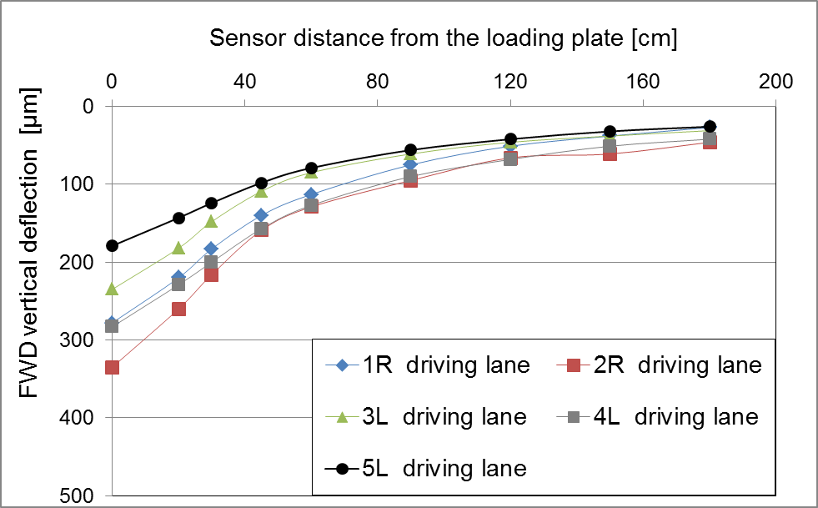
Figure 3. FWD - vertical deflection determined at five locations on the driving lane

Road investigations
The scope of investigations into the existing pavement consisted of the inspection and coring of asphalt layers 15 cm in diameter at several locations. At five locations the pavement and unbound base layers of the existing emergency lane were investigated with cores/pits 35 cm in diameter, and up to 70 cm in depth (Figure 4). Since in this climatic region the freezing depth is up to 60 cm below ground level, 70 cm is the usual investigation depth. The investigated locations were designated as 3L, 4L and 5L in the left emergency lane, and 1R and 2R in the right emergency lane.

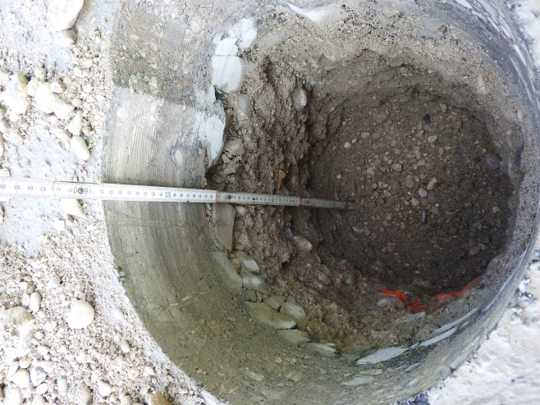
Figure 4. View of the trial pit at Location No. 3L

Underneath the asphalt layer, which had two layers, a ‘surf’ layer and a ‘base’ layer, with a total thickness of between 10 cm and 15 cm, there was a layer of crushed stones (graded similar to railway ballast). At a depth of 20 cm there was an unbound base layer, down to a depth of 70 cm. The gradation of the layer showed aggregate made from 0 to 32 mm stones, including fines. The results of sieving analyses showed that this material was susceptible to freezing – more than 8% of grains passed through the 0.063 mm sieve.
The dynamic modulus (E_{vd}) relating to the compaction stiffness bearing capacity of the subgrade was measured with a Light Weight Reflectometer in the five trial pits. The results obtained at various depths are presented in Figure 5. The thickness of the asphalt layer is designated as ‘Da’ and is also marked in the figure.

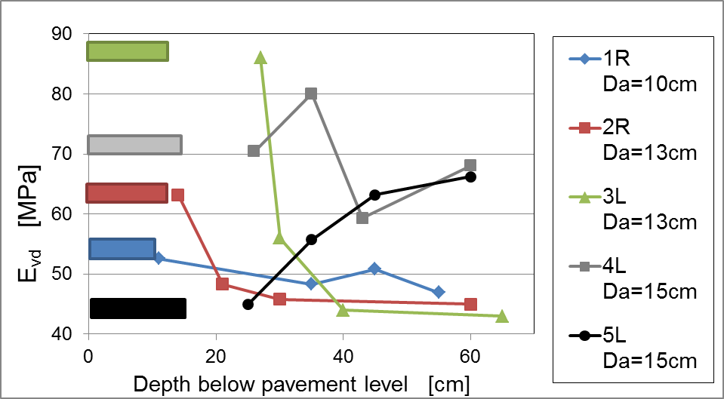
Figure 5. E_{vd} values measured at five locations together with corresponding asphalt thickness

From Figures 5 and 6 it can be concluded that there is good agreement between the results obtained by the two different methods. At locations 4L and 5L the compressive stiffness of the subgrade was relatively high, whereas at locations 1R, 2R and 3L the subgrade was much more compressible.
At the same five locations FWD tests were performed on the emergency lane with the same equipment as on the driving lane. The measured vertical displacements (the average of two measurements) are presented in Figure 6, and the corresponding CBR values are presented in Figure 7. The latter were calculated according to equations 1 and 2 [Garry W. Chai, 2013]

$CBR subgrade=2.6523{ . (D_{450})}^{-1.001}$ (2)

where D₄₅₀ is the deflection at a distance of 450 mm from the centre of the loading plate (in microns).

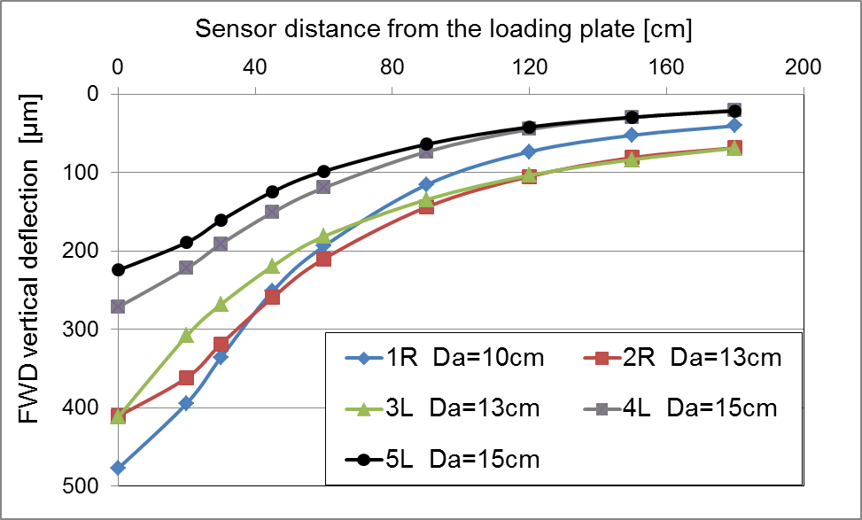
Figure 6. FWD - vertical deflection determined at five locations on the emergency lane

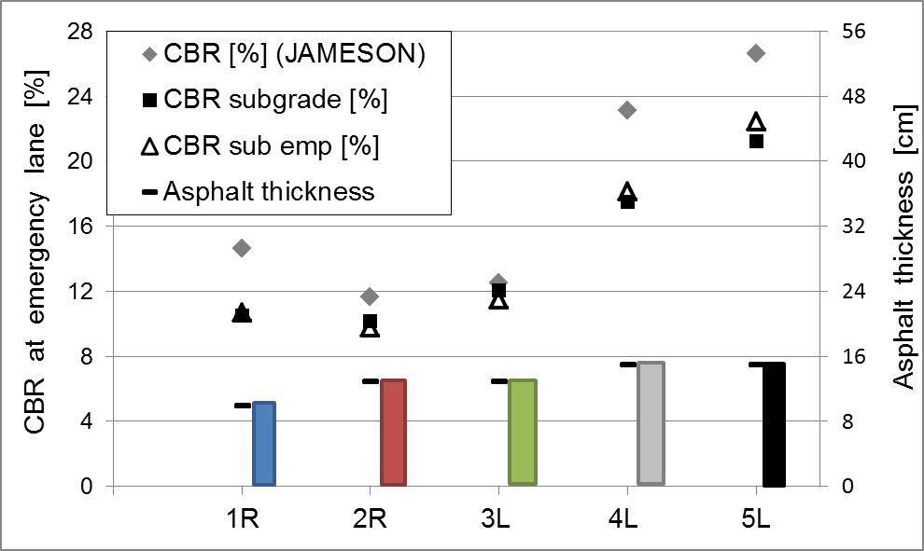
Figure 7. FWD – the results obtained at five locations on the emergency lane

The CBR values according to the Jameson equation (1) based on the results of the FWD measurements at 900 mm from the loading plate and (2) based on the results at 450 mm from the loading plate were evaluated. A relationship (3) for thin asphalt layers and a granular sub-base based on the deflection at a distance of 600 mm from the loading plate CBR_{sub emp} was empirically formulated. The results are presented in Figure 7. It was assumed that this equation could be used for further FWD measurements on the emergency lane along this road section.

${CBR}_{sub emp}=3.5{ . (D_{600})}^{-1.1}$ (3)

The two asphalt layers making up the thickness of all the layers in the driving and emergency lanes were investigated, and some basic bitumen tests (penetration, Ring and Ball, and Fraass fracture temperature) were performed in the driving lane ‘base’ layer.
Based on the performed road diagnosis it was concluded that the emergency lane needs upgrading ̶ unbound layers and at some locations also the natural subgrade of the emergency lane need to be completely replaced. It was also concluded that the bearing capacity of the driving lane unbound layers was sufficient, the base layer asphalt characteristics were acceptable and it was proposed that only the surface layer of the driving lane should be milled and overpaved (M. Turk, 2016).

Motorway DIAGNOSIS

Pavement monitoring
In the case of the examined two-lane motorway road section the driving speed is limited to 130 km/h. Due to the large increase in average daily truck traffic (AADTT) the pavement became heavily distressed (cracking and deflections occurred) and needed upgrading. The typical motorway configuration before upgrading, and the corresponding pavement distress (cracking and rutting), is shown in Figure 8.

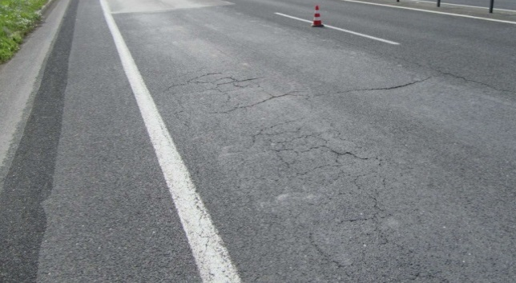
Figure 8. The investigated motorway section

In the case of higher driving speeds, the performance indicators, i.e. ride quality (International Roughness Index) and surface quality (rut depths, skid resistance), need to achieve relatively high prescribed threshold values. Skid resistance and longitudinal evenness as well as visual inspections, are therefore regularly performed.

Road investigations
The scope of investigations into the existing pavement of this 3 km long motorway section included the taking of numerous asphalt cores of diameter 15 cm. As well as this, six trial pits of diameter 35 cm, up to 70 cm in depth, were excavated, as well as two trial pits, up to 1.50 m in depth (Figure 9).

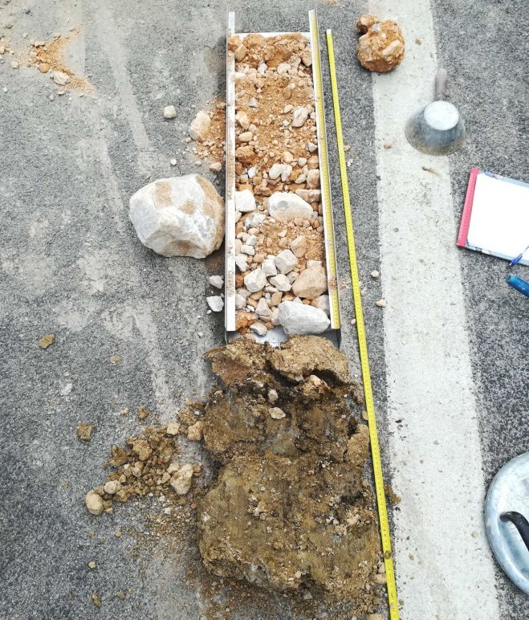
Figure 9. The road structure as determined in one of the trial pits

Beneath the 12 cm thick asphalt pavement, consisting of a ‘surf’ and a ‘base’ asphalt layer, there was a 10 cm to 20 cm cement stabilized layer, overlaying a layer of well-graded crushed aggregate 25 cm to 35 cm thick. Over the subgrade a capping layer of poorly graded crushed aggregate had been placed. The results of the sieving analyses of the unbound layers showed that they were not sensitive to freezing / thawing according to the criteria defined in the national technical regulations. In the case of the driving lane the cement stabilized layer was mostly deteriorated, although it was still in quite good condition on the less heavily trafficked lanes.
The results of the performed dynamic modulus (E_{vd}) measurements are shown in Figure 10. They showed good compressive stiffness in the unbound layers beneath the pavement, but at depths of more than 1.0 m, at the level of the natural subgrade, lower compressive stiffnesses were measured.
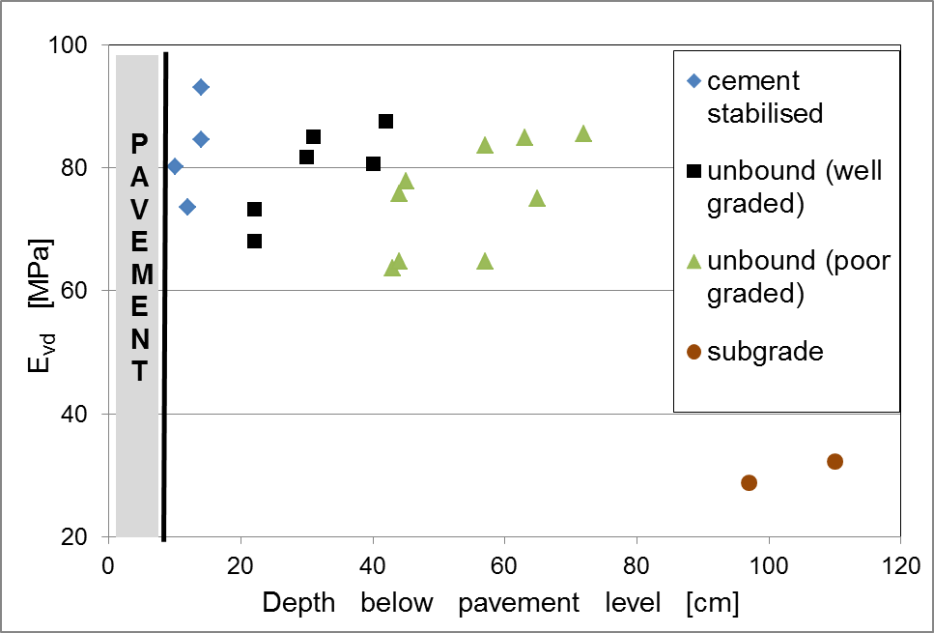
Figure 10. The E_{vd} results obtained at eight locations on the motorway section

Table 1. Bitumen characteristics of the ‘base’ layer
Bitumen content | Pene-tration | T_{R&B} | T_{Fraass}
[% (m/m)] | [mm/10] | [°C] | [°C]
3.8 | 15 | 64.4 | +1
3.4 | 14 | 79.6 | +5
3.2 | 16 | 65.4 | -1
3.2 | 13 | 76.0 | +4
3.8 | 17 | 72.4 | +4
3.1 | 17 | 69.0 | +2
3.5 | 17 | 64.6 | +1
3.8 | 16 | 67.0 | +2
3.8 | 15 | 64.4 | +1

The asphalt investigations consisted of the measuring of the thickness of the ‘surf’ and ‘base’ layers, and sieving analyses of a few samples. The investigations focused on the bitumen content [% (m/m)] in the asphalt, and the bitumen characteristics (penetration, Ring and Ball, and Fraass fracture temperature), in order to obtain preliminary information about the future site-won milled asphalt. Some of the results are shown in Tables 1 and 2. The tests included visco-elastic characterization using a Dynamic Shear Rheometer (DSR). Taking into account sustainability, the reclaimed asphalt aggregate will be used in the new asphalt mixtures.
It was proposed (M. Turk, 2018) that the asphalt layers down to the unbound layers should be milled, and that a completely new pavement structure be laid on top of this. Despite the deterioration of the cement stabilization layer into granular material, this layer is well compacted and conforms to the national criteria.

Table 2. Bitumen characteristics of the ‘surf’ layer
Bitumen content | Pene-tration | T_{R&B} | T_{Fraass}
[% (m/m)] | [mm/10] | [°C] | [°C]
4.5 | 18 | 65.6 | 0
4.7 | 16 | 65.8 | +2
4.4 | 18 | 63.8 | -4
4.4 | 15 | 65.4
4.4 | 10 | 84.4 | +5
4.4 | 14 | 68.0 | +1
4.6 | 15 | 64.2 | +1
4.6 | 16 | 64.2 | -1
4.5 | 18 | 65.6 | 0

accelerated load testing
In 2009 evaluation of the effect of different strengthening actions on weak pavement structures was performed by means of the accelerated load test (ALT) (M. Tušar, 2009). A Heavy Vehicle Simulator, HVS-Nordic (L. Wiman, 2006) was used to investigate six road structures having asphalt layers with different thicknesses. Six new instrumented (see Figure 12) local road sections with different thicknesses of asphalt layers were built, each with a length of 50 metres.

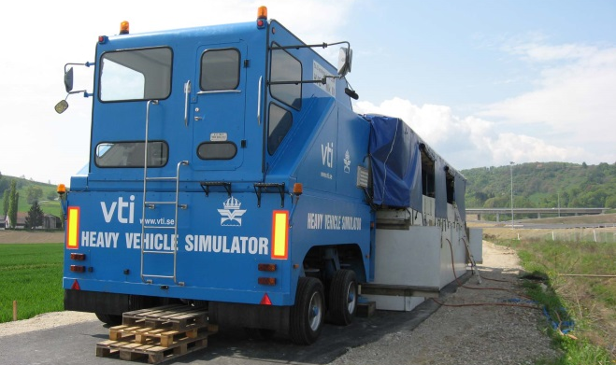
Figure 11. The HVS Nordic vehicle on a local road in 2009.

In tests performed by the HVS-Nordic vehicle (Figure 11) a loaded wheel moves at a constant air temperature and at a constant speed along a 6 m long section (the section is 8 m long in total) (R. Blab, 2004). The ALT tests were carried out at a pavement temperature of +20 °C and up to 300,000 passes of the HVS loading wheel were performed on each test structure (M. Tušar, 2015). The rut depth of the pavement was measured every day during the maintenance operations, and the deformations in the unbound layers were measured continuously during the ALT. Each test lasted for 2 weeks.
The natural subsoil consisted of silt and clay, on top of which a sub-base and an unbound base layer made of uncrushed gravel with grain size 0 to 32 mm were constructed. The total thickness of the unbound layers was up to 60 cm. This means that the road structure was similar to the emergency lane structure described in Section 2.
In order to determine the actual thickness of the unbound layers and the natural subsoil conditions, boreholes were drilled. The actual thickness of the asphalt layers was 65 mm at test structure 1 (TS1), 105 mm at TS2, 93 mm at TS3, and 136 mm at TS4. The results for the tests sections, designated TS3 and TS4, are presented in Figure 13.

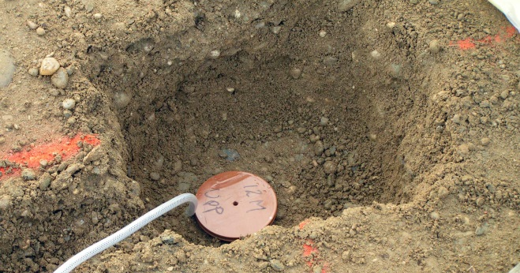
Figure 12. A measuring instrument for determining deflection of unbound layers

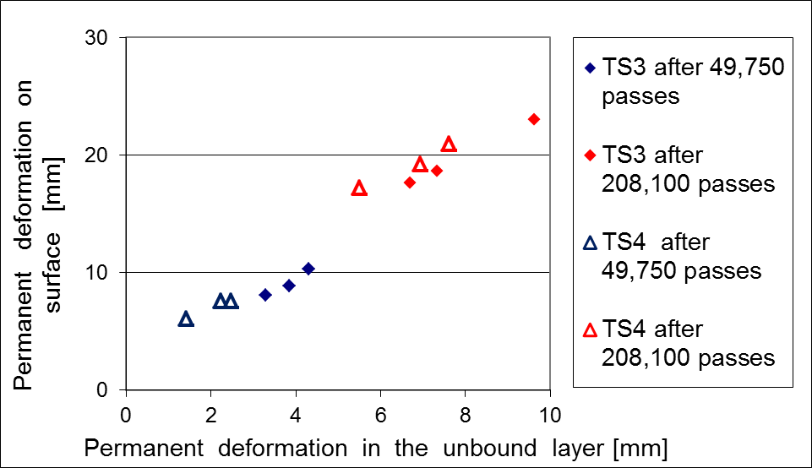
Figure 13. Permanent deformations measured at locations TS3 and TS4

As expected, the permanent deformation of pavement was higher than the measured permanent deformation in the unbound layers below. A clearly defined relationship between the size of the permanent deformation and the asphalt layer thickness was established in the case of relatively thin pavement structures. However, all the permanent deformations were of roughly the same size, and did not depend on the thickness of the asphalt at the other test structures. In the case of asphalt layers with a thickness greater than 9 cm the test results showed that most of the deformation at the surface was due to deformation in the unbound layer beneath the asphalt layers (M. Tušar, 2015).
From the ALT tests it can be concluded that in the case of weak road structures there is limit to the thickness of the asphalt layers which it is reasonable to construct. In the case of the studied test structures the optimal thickness of the asphalt layers was around 9 cm. When deep rutting is observed on roads with an asphalt layer thickness of 9 cm or less, this is most likely due to the weak granular unbound layers.

CONCLUSIONS
Only detailed investigations into the properties of the bound and unbound layers of constructed roads can lead to proper pavement maintenance decisions. Such investigations should include road monitoring and data base information, as well as asphalt and bitumen tests and the investigations of unbound layers.
For pavement monitoring on main roads, falling weight deflectometer (FWD) tests are used. The more detailed road investigations before reconstruction include the drilling of asphalt cores and trial pits to freezing / thawing depth. In such pits the dynamic modulus (E_{vd}) relating to the compaction stiffness bearing capacity can be measured.
In the case of asphalt layers, investigations include the determination of the thickness of all layers, the bitumen content [% (m/m)] in the asphalt, and tests of the bitumen like penetration, Ring and Ball, and Fraass fracture temperature. Investigations into the properties of existing (old) asphalt should also focus on other bitumen characteristics such as ductility, viscosity (Dynamic Shear Rheometer tests), and on low temperature characteristics determined by Bending Beam Rheometer tests, in order to obtain preliminary information about future site-won milled asphalt. Taking into account sustainability, the reclaimed asphalt aggregate should be reused in the preparation of new asphalt mixtures.
From the results of the ALT tests it can be concluded that, in the case of weak road structures, there is limit to the thickness of the asphalt layers which it is reasonable to construct. In the case of the studied test structures the optimal thickness of the asphalt layers amounted to around 9 cm.
The road upgrading process should include experts from different fields of civil engineering in order to optimize road upgrading decisions.

References
Eurostat 2017, ISSN 2443-8219 https://ec.europa.eu/eurostat/statistics-eplained/index.php/Road_freight_transport_statistics
Chai, G.W., Argadiba S., Stephenson G, Condric I., Oh E Y., Manoharan S. P. 2013. Prediction of Subgrade CBR using FWD for thin bituminous pavements, International Journal of Pavement Research and Technology, 280 - 286
Turk, M. R. 2016. Report on the results of investigations to determine the quality of existing materials of a pavement structure, ZAG Ljubljana, Slovenia.
Turk, M. R. 2018. Report on the results of investigations to determine the quality of existing materials of a pavement structure, ZAG Ljubljana, Slovenia.
Tušar M., Turk M.R., Wiman L., Kokot D., Lenart S. 2009. Guidelines for selection of the most convenient upgrading systems based on results of heavy vehicle simulator, 6th FW project SPENS Deliverable, Ljubljana.
Wiman L. 2006. Accelerated Load Testing of Pavements – HVS Nordic tests at VTI Sweden 2003-2004, VTI report 544A, Linköping, Sweden.
Blab, R., Wiman, L., Litzka, J., Ruttmar, I. 2004. Heavy Vehicle Simulator Experiment on a Cement Stabilized Pavement Structure in Poland, 2nd International Conference on Accelerated Pavement Testing, Minneapolis, Minnesota.
Tušar M., Turk M.R. 2015. Accelerated load tests with a heavy vehicle simulator, Građevinar, 67, 647-654.

