Determination of undrained shear strength by the Fall Cone Method – Analysis, concept and guidelines
La determination de la résistance au cisaillement non drainé par la Méthode de Fall Cone – L‘analyse, les concepts et les orientations
C. W. Clemente
Universidade Federal do Paraná/Fugro, Curitiba, Brazil
V. P. Faro
Universidade Federal do Paraná, Curitiba, Brazil
M. P. H. Moncada
Universidade Federal Fluminense, Rio de Janeiro, Brazil

ABSTRACT: The undrained shear strength is the shear strength mobilized by the soil when it is rapidly loaded without interstitial water drainage conditions and it can be determined through field and laboratory tests. The aim of the present research is to determine the undrained shear strength by the Fall cone test, developed by John Olsson in Sweden between 1914 and 1922. To evaluate the applicability of the equipment, the undrained shear strength was obtained by other tests, such as laboratory vane test and unconsolidated undrained triaxial test. There were tested 16 Brazilian soil samples with different geotechnical characteristics and offshore origin. The Fall cone test is compatible with conventional tests (triaxial UU test and laboratory vane test) and has a fast execution, it can be considered as an alternative to complement and support undrained shear strength estimates from soft soils.

RÉSUMÉ: La résistance au cisaillement non drainé est la résistance mobilisée par le sol quand il est rapidement chargé lorsque celui-ci est chargé rapidement et sans conditions de drainage de l'eau interstitielle et qu'il peut être déterminé par des tests sur le terrain et en laboratoire. L’objectif de la présente recherche est de déterminer la résistance au cisaillement non drainé à l’aide du test du Fall Cone développé pour John Olsson en Suède entre 1914 et 1922. Pour évaluer l’applicabilité de l’équipement, la résistance au cisaillement non drainé a été obtenue pour autres tests, tels que essai en laboratoire et essai triaxial non consolidé non consolidé. Il a été testé 16 échantillons de sol brésiliens présentant différentes caractéristiques géotechniques et d'origine offshore. Le test du Fall Cone est compatible avec les tests conventionnels (triaxial UU test et laboratory vane test) et son exécution est rapide. Il peut être considéré comme une alternative pour compléter et soutenir les estimations de la résistance au cisaillement non drainée des sols meubles.

Keywords: Undrained shear strength; Fall cone test; Marine samples.

introduction
For the determination of geotechnical parameters in soft soils, some situations should be considered, such as natural variability of the ground, acquisition of experimental data, stability analysis, as well as resistance, deformability and hydraulic conductivity parameters (LEMOS, 2014).
The undrained shear strength is an important parameter in geotechnical engineering projects, known as the shear strength that the soil has when requested by rapid loading without drainage of the interstitial water. It can be determined through field and laboratory tests. The following tests can be used in the laboratory: simple compression, unconsolidated undrained triaxial (UU), Fall cone test (FCT) and laboratory vane test (LVT). Fall cone and laboratory vane tests have advantages such as simplicity, speed and low cost in which the measurements of undrained shear strength are obtained, allowing a greater number of tests in a given sample when compared with the classics tests (LEMOS, 2014).
The Fall cone or Swedish cone was created between 1914 and 1922 to quickly and easily obtain liquid limit and undrained shear strength, which has encouraged many countries, such as Canada, Sweden, and England, to adopt it as standardized equipment (TANAKA et al, 2012).
One of the practical advantages of Fall cone is that the test can be performed in a few minutes, obtaining the result of resistance through a simple formulation and allowing quick identification of a clay in terms of the index and physical properties (GARNEAU; LEBIHAN, 1977). In the laboratory vane test, the influence of time can interfere with the results in two distinct ways, first in the delay between the insertion of the vane and the beginning of the rotation, and the speed of rotation (PÉREZ-FOGUET et al., 1998). The unconsolidated undrained triaxial test (UU) is considered fast because there is no drainage during the test and has no phase of consolidation, so the time factor depends mainly on the chosen shear rate.
The purpose of this paper is to demonstrate the applicability of the device in Brazilian soils to determine undrained shear strength, verifying if the values obtained are consistent when compared to the classic tests.

MATERIALS AND METHODS
Fall cone equipment is a simple and fast method for the determination of undrained shear strength, which can be interpreted in terms of simple mechanics (KOUMOTO and HOULSBY, 2001). It can also determine the sensitivity and liquid limit. The Fall cone method consists of a metal cone of a certain mass with a certain angle suspended on the horizontal surface of a soil sample, only with the tip of the cone touching the surface. The cone is released under its own weight and the cone penetration in the sample is measured (KARLSSON, 1961). The equipment is represented in the following figure:
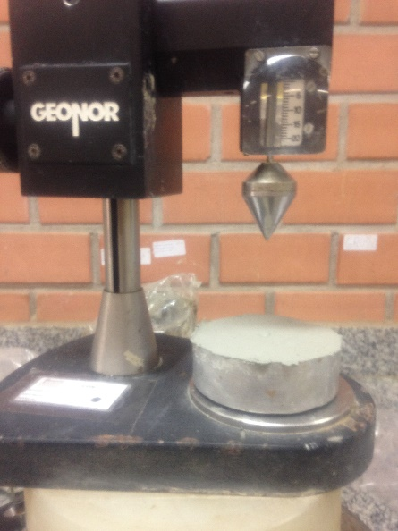
Figure 1. Fall cone

The test procedure was performed according to ISO 17892-6 - "Geotechnical investigation and testing - Laboratory testing of soil - Part 6: Fall cone test", in each test 3 determinations were performed, each point distant from each other around of 25 millimeters.
The "cone type" variable was evaluated with the intention of defining which cone is best applicable to Brazilian soil samples and which presents a better correlation with the more usual tests in the practice of geotechnical engineering in the country. Three types of the cone were used to determine undrained shear strength in undisturbed and disturbed samples: mass of 100 grams and angle of 30º denominated Cone 1, mass of 60 grams and angle of 60º denominated Cone 2 and mass of 10 grams and 60º angle designated as Cone 3.
Another relevant variable for the evaluation of the Fall Cone test is the size of the recipient in which the disturbed sample is placed, this recipient varies according to the standard considered. The purpose was to evaluate the influence of dimension, height, and diameter, on the results of undrained shear strength. In the present work, four types of containers will be considered: the sampler itself, ISO 17892-6, the container considered by Karlsson (1981) and the cylindrical aluminum container used in a previous work by the author.
The undrained shear strength calculation by Hansbo in 1957 considers that the shear strength of a soil in kPa is proportional to the mass of the cone (Q) and inversely proportional to the square of the penetration (P), g is the (g = 9.81 m / s²), the coefficient K depends on the cone opening angle, the shear rate and the sensitivity of the clays.

$Su=K.g.\frac{Q}{P²}$ (1)

The samples used in the present study come from a region of Baixada Fluminense. The samples are undisturbed and have different geotechnical characteristics with depths varying from 0.91 to 12.40 meters. In order to have a good range of results in the present work, tests were performed on 16 samples.
The table 1 shows the characteristics of the samples used in the present work.

Table 1. Samples
Sample | Moisture content | Specific weight
1 | 48.0 | 1.74
2 | 50.4 | 1.64
3 | 53.9 | 1.67
4 | 122.2 | 1.36
5 | 88.0 | 1.48
6 | 74.9 | 1.48
7 | 90.9 | 1.49
8 | 79.7 | 1.47
9 | 45.8 | 1.73
10 | 44.3 | 1.74
11 | 43.9 | 1.75
12 | 38.3 | 1.81
13 | 52.0 | 1.68
14 | 34.0 | 1.80
15 | 46.3 | 1.74
16 | 48.6 | 1.72

RESULTS AND DISCUSSIONS
The first aspect evaluated in this item will be the undrained shear strength and the test penetration for the three cone types. The undrained shear strength was calculated by the formula of ISO17892-6 with the application of a correction factor (μ) according to the liquid limit executed by the Cone method.

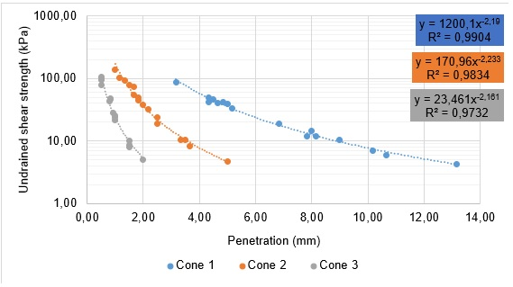
Figure 2. Undrained shear strength versus penetration (Undisturbed condition)
The trendline that best fit the undrained shear strength versus penetration plots for the undisturbed condition was the potential trend line.
Considering all the results obtained, the R² value was 0.3412, indicating an inconsistent adjustment. However, when analyzed individually, the lines for each cone have adequate R² values, above 0.97, showing a good correlation between the obtained results. In this graph, it can be observed that each cone generates a differentiated slope of the others, confirming that the penetration is inversely proportional to the values of undrained shear strength.
The variations between the penetrations for the three cones for the same sample are not constant, due to the anisotropy of the soils and the parameters of opening angle and mass of each cone.
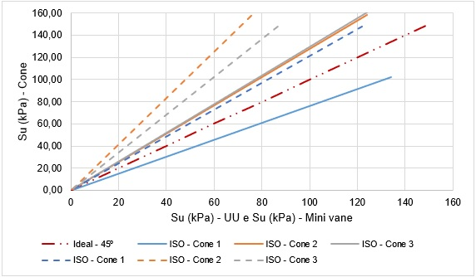
Figure 3 - Comparison between Fall cone, laboratory vane test and triaxial UU

It is observed that the results obtained by the cone are larger than the results obtained by the vane test and triaxial UU test. Considering the triaxial UU test results for cone 2 and 3, the trend lines were very close to each other and above the ideal line. In some cases, such as results of undrained shear strength to cone 2 compared to laboratory vane test results, the undrained shear strength by the cone becomes 50% greater than by the laboratory vane test. The laboratory vane test in their individual results had already presented irregular curves in which some associated error was committed, so it would be interesting to re-evaluate this test taking into account its variables and particularities and then, to compare again with the cone.
In general, for undisturbed condition cone 3 would not be the most appropriate option for performing the cone tests due to the low penetrations reached.
For the remolded condition, the first consideration will be how much the values of undrained shear strength and the penetration measured during the Fall cone test for the three types of cone and the different containers studied. The trendline that best fit for the undrained shear strength vs. penetration plots for the remolded condition was the potential trend line as previously seen in the undeformed condition.
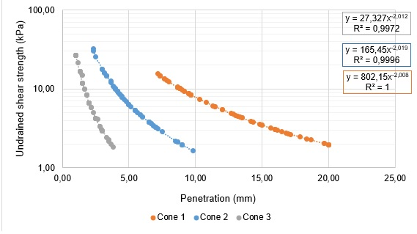
Figure 4. Undrained shear strength versus penetration (Remoulded condition)

A different inclination of the others is also observed for each type of cone, again confirming that the penetration is inversely proportional to the values ​​of undrained shear strength. As for the undisturbed condition, when analyzed by cone, the trend lines for each cone have consistent R² values, above 0.99, showing a good correlation between the obtained results. Recalling that for each cone are being considered all the results obtained by the containers studied.
The variations between the penetrations for the three cones for a same sample are not constant, but for this condition the values ​​present a pattern of behavior: the penetration difference between the values ​​of cone 1 and 2 is of at least 1.3 times the difference between the values ​​of cone 2 and 3. When evaluated the penetrations in the different containers studied for the same cone and for the same sample, the values ​​are similar, varying around 2 millimeters for penetrations of up to 10 millimeters. For larger penetrations, the values ​​present differences of up to 4 millimeters.
The cone 1 (100 grams and opening angle of 30 °) was the cone that best suited for the remolded condition and is in line with the ISO17892-6 penetration range recommendation. In cone 2 there are values ​​that fit the range provided by the standard, however they are not all values ​​and cone 3 is below the minimum accepted by the standard. As for the undisturbed condition, it may be said that the smaller penetrations are imprecise and point out exaggerated undrained resistor values.
By comparing the results of cone and laboratory vane test, the values ​​obtained for the cone are smaller than the values ​​for the vane test, except in the case of the assay using the cone 3 performed on the sampler. In certain situations, the values ​​show good convergence and in others, the results indicate considerable variability. The curves closest to the ideal were the results obtained by the cone 3 in the ISO container and the sampler and by the cone 2 in the sampler. Cone 1 had the lowest correlations among the evaluated ones.

Conclusions
In this experimental study, the inverse proportional relation of the undrained shear strength and the penetration proposed by Hansbo in 1957 was confirmed. The calculation of determination of resistance not drained by the formula of ISO17892-6 tends to overestimate the resistance values due to the low penetrations, demonstrating values that are not consistent with reality and therefore should be used with caution. The lightest cones for these materials had low penetrations of the order of 0.5 to 3.8 millimeters, and verifying through the scale of the equipment can be considered as imprecise or inconsistent values.
It can be stated that the cone tests are compatible with the conventional tests of triaxial UU and laboratory vane test, but depending on the cone used, a factor that should always be considered. For the fast determination of the undrained shear strength, the cone test is a simple and fast method to perform, allowing a greater number of determinations in a same sample and a small amount of sample is necessary for the execution of the test, which allows the use as a form complementary to the classic tests. The differences in values observed with respect to the classic tests do not allow to assert that the test is used alone, and a redundancy is always necessary to confirm the data, because as shown in this research depending on the cone used, the undrained shear strength can be overestimated.

Acknowledgments
The authors are grateful to Federal University of Paraná and Fugro In Situ Geotecnia for the encouragement and assistance in the preparation of this paper.

References
Internation Organization for Standardization. ISO 17892: Geotechnical investigation and testing - Laboratory testing of soil – Part 6: Fall cone test. 2014.
Garneau, R.; Le Bihan, J. P. 1977. Estimation of some properties of Champlain clays with the Swedish fall cone, Canadian Geotechnical Journal, Vol. 14, p. 571 – 581.
Hansbo, S. 1957. A new approach to the determination of the shear strength of clay by the Fall-Cone test. Royal Swedish Geotechnical Institute, Proceedings nº 14. Estolcomo.
Head, K. H. 1994. Manual of Soil Laboratory Testing. v. 2. John Wiley & Sons Inc.
Hvorslev, M. J. 1949. Subsurface exploration and sampling of soils for civil engineering purposes, Waterways Experiment Station, Vicksburg/USA.
Karlsson, R. 1981. Consistency limits: a manual for the performance and interpretation of laboratory investigations, Swedish Council for Building Research, Part 6.
Lemos, S. G. F. P. 2014. Estudo da resistência não drenada de solo de baixa consistência por meio de ensaios de campo e laboratório. Dissertação em Mestrado em Engenharia Civil. Universidade Federal do Espírito Santo, Vitória/ES, 183 f.
Leroueil, S.; Le Bihan, J. P. 1996. Liquid Limits and fall cones, Canadian Geotechnical Journal, Vol. 33, p. 793 – 798.
Pérez-Foguet, A.; Ledesma, A.; Huerta, A. 1998. Analysis of the vane test considering size and time effects, Journal for Numerical and Analytical Methods in Geomechanics, nº 122.
Sridharan, A.; Prakash, K. 1998. Liquid limits and fall cones: Discussion, Canadian Geotechnical Journal, v. 35, p. 407 – 408.
Tanaka, H.; Hirabayashi, H.; Matsuoka, T.; Kaneko, H. 2012. Use of fall cone test as measurement of shear strength for soft clay materials, Soils and Foundations, v. 52, p. 590 – 599.

